LOST CANINE GUIDANCE

Q What do we mean by “Lost Canine Guidance”?

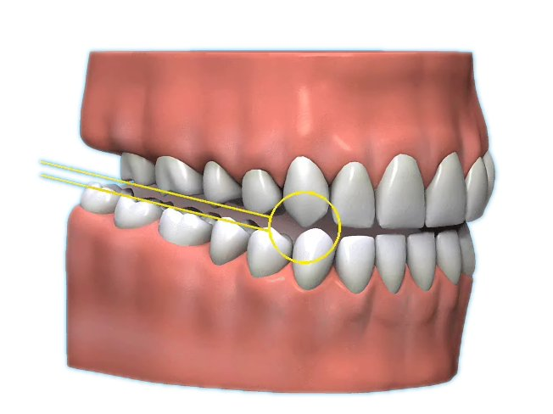
A Lost Canine Guidance occurs naturally because the long and strong canines withstand the chewing forces when the lower jaw moves from side to side. The top and bottom back teeth do not touch each other.

Q How is this protection lost?

Wear and tear on the tips of the canines, often from tooth grinding (called bruxism) allows the top and bottom back teeth to come into contact. This is called “group function”.

Q Is group function bad?

A Any back teeth weakened by fillings are prone to fracture if the canine protection is lost.

Q So how is canine protection regained?

A The simplest method is to add white fillings (composite) to the tips of the worn canines. If the front teeth are crowned then canine guidance can be built into the shape of the crowns.

Q What will my teeth look like after treatment?

A They will look like they did before any wear and tear and feel strangely longer initially.

Q What if it happens again?

A It takes years for the wear and tear to occur, but the treatment can be repeated.

Q Is it expensive?

A Crowns and veneers are expensive but white composite fillings are much cheaper.

Q What if I don’t have the treatment?

A The wear and tear will continue and the back teeth may fracture repeatedly.

Q Will the teeth be safer after treatment?

A Canine protected guidance should ensure the back teeth will be safer.

Q What about aftercare?

A There is no special aftercare, your teeth should be cleaned as normal.
